CALL FOR THE ISSUE 35 of EX ÆQUO:
*INTERSECCIONALITY, COMUNICATION AND CULTURE: CROSSOVERS MATRICES OF OPPRESSION AND PRIVILEGE*
Guest Editors: Carla Cerqueira – Centro de Estudos de Comunicação e Sociedade da Universidade do Minho e Universidade Lusófona do Porto
Sara Isabel Magalhães – Centro de Psicologia da Universidade do Porto, Faculdade de Psicologia e Ciências da Educação da Universidade do Porto .

Deadline: 30 December (for publication in May 2017)

Gender and/or Feminist Communication and Culture Studies begin to show a strong consolidation at the academia, whether at an International level or in the Portuguese context. In this area of research it is increasingly important to deconstruct a social categorization that promotes and reifies asymmetries of power, the single axis and universal gender thinking; and seek to question matrices of domination and subordination, inequalities and privileges.
The thematic dossier presented here aims to compile theoretical, methodological and empirical proposals focused in the area of communication and culture, based on an intersectional position (Crenshaw 1991; Nogueira 2011, 2013; May 2014; McCall 2005). This perspective is meant to emphasize the existence of multiple axes of inequality; still it is not limited to the mere addition of categories, but the interlacing with gender - although not in a hierarchical matrix (May 2014) - which is proposed as part of a political promotion of equality, citizenship and of democratic system (McCall 2005; Nogueira 2011, 2013).
Therefore this call for papers invites the submission of proposals from different disciplines of national, international and/or comparative scope, seeking to rebut singular and delimited categorical approaches, which clearly adopt stances of under- or over- group inclusion and thus ignore concrete experiences of individuals who position themselves at the intersection of various social groups (Crenshaw 2002). Thus, we intend to reflect on the study of communication and culture starting from a broad proposal, theoretical and policy, which aims to escape the social matrix that "subject intersectionality to epistemic forms of domination that aims to deconstruct" (May 2014, 95). Noteworthy, finally, the importance of looking at the communication and culture in its many variants as elements / deconstruction instruments hierarchies of personhood by promoting closer representations of individual idiosyncrasies; but also stimulating a literacy promotion for the sociocultural diversity.
Entrenched in a contemporary feminist perspective, that goes beyond the issues of men and women and that includes a "much broader spectrum, for its hyphenation [...] with other movements and other social and political concerns" (Oliveira 2015, 75), this thematic dossier of ex aequo seeks to give voice and visibility to contributions which have as their object of analysis intersectionality in the study of communication and culture.
These include, but are not excluded by default from others in the same scope of work, proposals reflecting theoretical, methodological and empirical about the following:
- Reflections that perspective gender studies and feminist media at its opening to the theory of intersectionality.
- Theoretical and methodological conceptualizations on the integration of the theory of intersectionality in the study of communication and culture.
- Critical analysis, based on the theory of intersectionality, applied to several axes of communicational and culture production (production, representation and / or reception).
- Reflective reviews of multi-determined structures of oppression and privilege and their potentiation in / by the media.
- Reports, mediated, of visibility processes, "voicing" and meaning facing of, intra- and inter-categorical, matrixes of privilege and oppression.
- Critical assessment of public policy and / or professional integration of diversity practices by / in media production.
- Intersectional placements that reflect on the uses and potential of media and cultural literacy.
- Studies on movements and protest actions of multi-oppressive power hierarchies within the culture and communication fields.

Refereces:
Crenshaw, Kimberlé. 1991. «Mapping the Margins: Intersectionality, Identity, Politics and Violence Against Women of Color». Stanford Law Review 43, 1241-99.
Crenshaw, Kimberlé. 2002. «Documento para o encontro de especialistas em aspetos da discriminação racial relativos ao género». Estudos Feministas 1, 171-188.
May, Vivian M. 2014. «‘Speaking into the Void?’. Intersectionality critiques and Epistemic Backlash». Hypatia 29(1), 94-112.
McCall, Leslie. 2005. «The complexity of intersectionality». Signs 30(3), 1771-1800.
Nogueira, Conceição. 2011. «Introdução à teoria da interseccionalidade nos Estudos de Género». In Género e Ciências Sociais, ed. por Sofia Neves, 67-78. Maia: Edições ISMAI.
Nogueira, Conceição. 2013. «A teoria da Interseccionalidade nos estudos de género e sexualidades: condições de produção de “novas possibilidades” no projeto de uma psicologia feminista crítica». In Práticas Sociais, políticas públicas e direitos humanos, ed. por Ana Lídia Brizola et al., 227-248. Florianópolis: Abrapso/Nuppe/CFH/UFSC.
Oliveira, João M. 2015. «Mil Géneros». Vírus 7, 74-76.

Deadline and guidelines for submission
All submissions have to abide by the publication guidelines of ex æquo, which are available at http://www.apem-estudos.org/en/page/apresentacao-da-revista, and the papers should be sent until 30 of December, to the e-mail apem1991@gmail.com. The submissions that do not abide by the publication guidelines of ex æquo (e.g. references, tables and figures, article length) will be immediately excluded from the arbitrage process. Within four weeks after submission, the authors will receive an email informing of the decision to send the paper for peer review or the exclusion from the arbitrage process. The date due for publication of this special number is May 2017.

The call for non-themed submissions (articles and reviews) is continuously open.

ex æquo
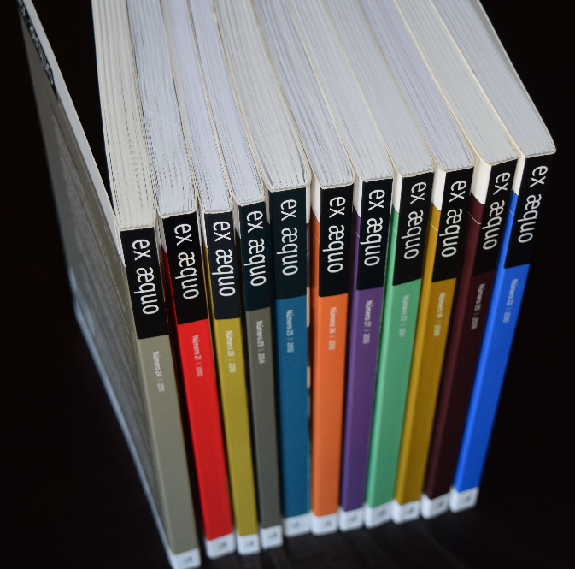
ex æquo is a scientific, interdisciplinary and multidisciplinary peer reviewed journal open to contributions of multiple disciplines and currents of thought. A bi-annual interdisciplinary journal in the area of Women’s, Gender and Feminist Studies (http://www.apem-estudos.org/en/page/apresentacao-da-revista)
ex æquo invites submissions of original papers, both to the thematic dossiers and the studies and essays caption, and book reviews. The Journal is edited by the Portuguese Association of Women’s Studies (APEM) and is directed to an international audience, accepting manuscripts submitted in Portuguese, English, French and Spanish, from various countries. It aims to ensure that the articles published make a significant contribution to the advance of knowledge. Articles submitted for publication undergo a blind independent review by at least two recognised specialists drawn from a range of countries.
Indexed in:
SciELO Citation Index da Thomson Reuters: SciELO Citation Index - http://apps.webofknowledge.com/SCIELO ;
SciELO/Portugal – Scientific Eletronic Library Online: http://www.scielo.mec.pt/scielo.php?script=sci_serial&pid=0874-5560&lng=pt ;
Catálogo Latindex – Sistema Regional de Información en Línea para Revistas Científicas de América Latina, el Caribe, España y Portugal: http://www.latindex.unam.mx/latindex/ficha?folio=14734 ;
ERIH PLUS (European Reference Index for the Humanities): https://dbh.nsd.uib.no/publiseringskanaler/erihplus/periodical/info?id=482587.
Listed in:
-CAPES/Brasil http://qualis.capes.gov.br/webqualis/publico/pesquisaPublicaClassificacao.seam (Class. QUALIS: Interdisciplinary – B1; Sociology – B2; Applied Social Sciences I; Psicology; Education – B3);
- Virtual Library of Women's History (http://www.iisg.nl/w3vlwomenshistory/ )

